Cellular automata multiplayer online game

Starting as a 2-player online game, the user will wait for an opponent and once the opponent is found, the game will begin, following these steps:

1. Step 1: Map generation

A simple 2D square grid of size, let’s say, 20x20, that is partitioned such as each player would get the same amount of territory:



This is what player I will see, the grey areas meaning: restricted territory (he cannot activate cells in this territory; he can only activate cells in the white territory). Player II will see exactly the opposite: white becomes grey and vice versa.

1. Step 2: Initial configurations

Each player will activate cells as to create the most favorable initial configuration for himself. This process will finish after some time runs out.

1. Step 3: Automata Evolution

We will now analyze a simplified case of automata evolution that can happen during the game:

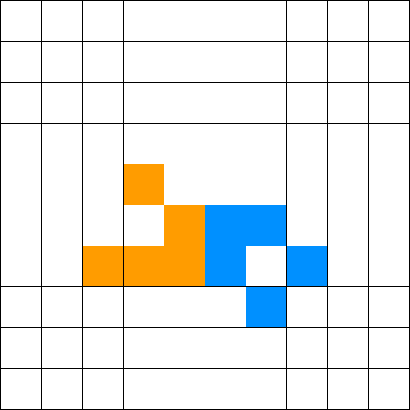We will start from the following initial configuration:

Here, player I has the orange cells and player II the blue ones.

The rule we’ll be using is Conway’s Game of Life (CGOF) (in the future, the game could accommodate multiple rules, that can be applied to different cells, so as to make it more interesting and stop players from abusing the “best” patterns).

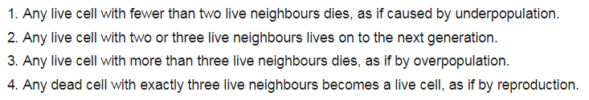

We can see in the picture that player I has a “Glider”, a pattern of CGOF under the category: “spaceship” (for the way it “moves”). Player II has a “Boat”, a “still life” (for its lack of “movement”).

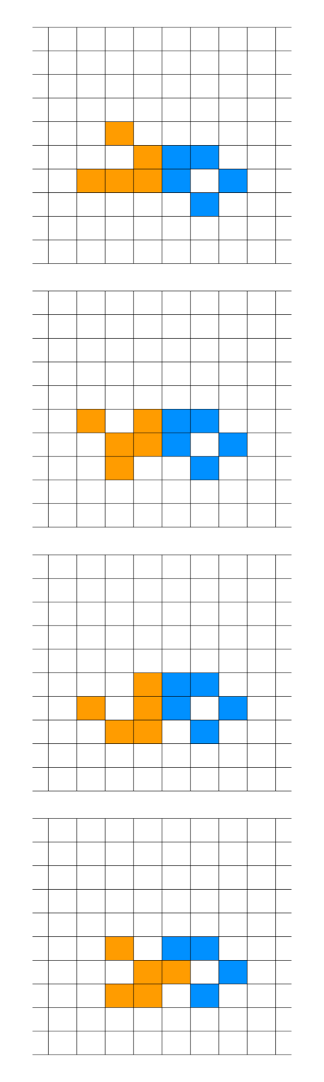The initial configuration evolves as follows:

The last panel shows how a cell can overwrite an opponent cell.

At each iteration of the evolution, the transitions for a player are calculated as if the opponent’s cells are all dead. The only problem here would be the case when a cell wants to be activated with orange and blue at the same time. In this case the cell will remain dead.

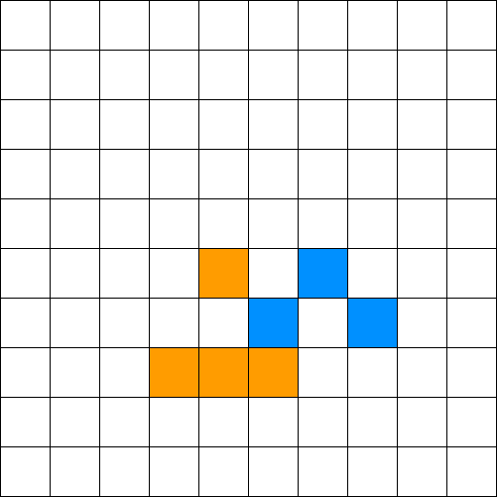Getting back to the evolution, the next state is:

To analyze how we arrived at this state we will use this:

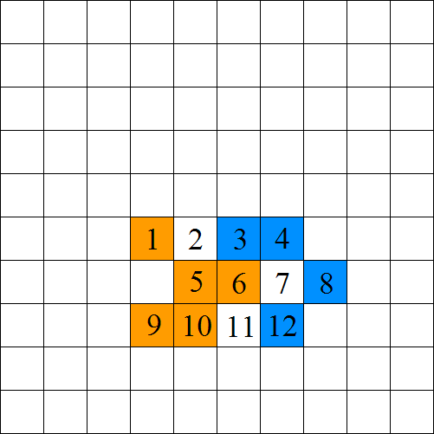

Cell 1: died because of rule 1

Cell 2: was born because of rule 4; neighbors: {1,5,6}

Cell 3: died because of rule 1

Cell 4: lived because of rule 2

Cell 5: died because of rule 3

Cell 6: was reborn as a blue cell because of rule 4; neighbors: {3,4,12}

Cell 7: stayed dead

Cell 8: lived because of rule 2

Cell 9: lived because of rule 2

Cell 10: lived because of rule 2

Cell 11: was born because of rule 4; neighbors: {5,6,10}

Cell 12: died because of rule 1

The next state is:

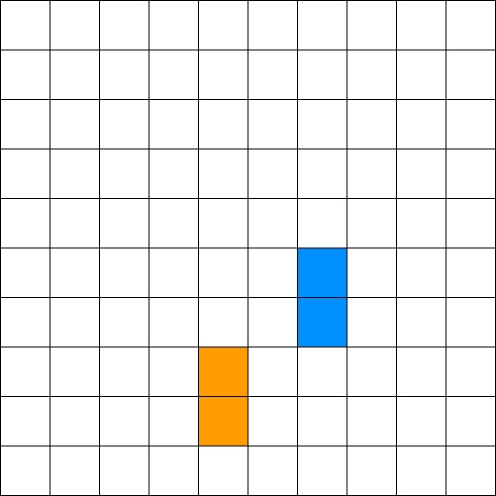

After this state follows simultaneous death for both players’ cells.

Who wins then?

Normally, the player who still has cells on the board wins, but this situation is an exception where the game ends in a draw. To avoid a draw, we keep track of how many cells each player has in each iteration and at the end we sum them to obtain the total and give the victory to the player with the most points.